Experiment Number : 02 Date: 25-01-26

Input and Output Statements in Java
Aim:
To understand and use input and output statements in Java using the Scanner class.
PRE LAB EXERCISE
QUESTIONS
What is input in a program?
Input is the data that a user gives to a program.
Examples of input:
- Entering a number
What is output in a program?
Output is the result that the program displays.
Examples of output:
- Printing the cube of a number
Which class is used to read input from the user in Java?
The class used is:
Scanner class
It is present in the package:
import java.util.Scanner;
Why Scanner?
- It reads input like integers, strings, float, double, etc.
- Commonly used in Java programs for user input.

IN LAB EXERCISE
Objective:
To read input from the user and display the output using Java input and output statements.
INPUT STATEMENT:
SCANNER CLASS
- The Scanner class in Java is used to read input from the user through the keyboard.
It is available in the package java.util.
- The Scanner object reads different types of input such as integer, float, double, and string and stores them in variables.
- To use the Scanner class, it must be imported before using it in the program.
SYNTAX:
- Scanner sc = new Scanner(System.in);
Commonly Used Scanner Methods:
- nextInt() – reads an integer value
- nextFloat() – reads a float value
- nextDouble() – reads a double value
- next() – reads a single word
- nextLine() – reads a complete line of text

PROGRAMS:
Program 1: Read and Display Name
Source Code:
import java.util.Scanner;
class ReadandDisplay {
public static void main(String[] args) {
Scanner sc = new Scanner(System.in);
System.out.print("Enter your name: ");
String name = sc.nextLine();
System.out.println("Your name is: " + name);
}
}
Output:
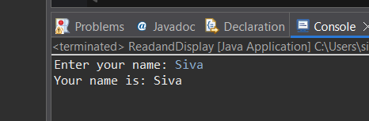
Program 2: Read Two Numbers and Print Sum
Source Code:
import java.util.Scanner;
class Sum{
public static void main(String[] args) {
Scanner sc = new Scanner(System.in);
System.out.print("Enter first number: ");
int a = sc.nextInt();
System.out.print("Enter second number: ");
int b = sc.nextInt();
int sum = a + b;
System.out.println("Sum = " + sum);
}
}
Output:
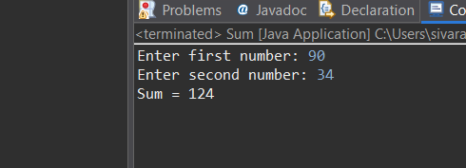
Program 3: Read Length and Breadth and Find Area of Rectangle
Source Code:
import java.util.Scanner;

class AreaRectangle {
public static void main(String[] args) {
Scanner sc = new Scanner(System.in);
System.out.print("Enter length: ");
int length = sc.nextInt();
System.out.print("Enter breadth: ");
int breadth = sc.nextInt();
int area = length * breadth;
System.out.println("Area of Rectangle = " + area);
}
}
Output:
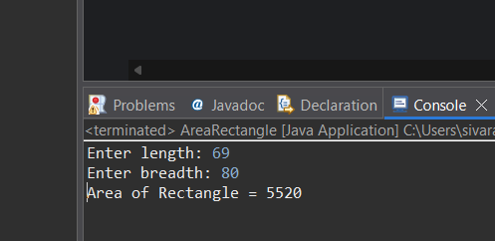

POST LAB EXERCISE
- What is the use of the Scanner class in Java?
The Scanner class is used to read input from the user (keyboard input).
It can read:
- integers
- strings
- floating values
- characters (through strings)
- Which package contains the Scanner class?
The Scanner class is in the:
java.util
package.
So we import it as:
import java.util.Scanner;

- What does System.in represent?
System.in represents:
👉 Standard input stream
👉 Usually keyboard input
The Scanner class uses System.in to read user input.

- What does System.out represent?
System.out represents:
👉 Standard output stream
👉 Used to display output on the screen
System.out.println() prints output.

- Name any two methods used to read input using Scanner.
Common Scanner methods:
- nextInt() → reads an integer
- nextLine() → reads a whole line of text
- next() → reads a single word
- nextDouble() → reads a double
- nextFloat() → reads a float
Any two:
✔ nextInt()
✔ nextLine()
- What is the difference between next() and nextLine()?
Method | What it reads | Stops when
next() | Reads a single word | Stops at space
nextLine() | Reads the entire line | Stops at enter

Result:

Thus the input was successfully read from the user and the corresponding output was displayed using Java input and output statements.

ASSESSMENT

Description | Max Marks | Marks Awarded
Pre Lab Exercise | 5
In Lab Exercise | 10
Post Lab Exercise | 5
Viva | 10
Total | 30
Faculty Signature

